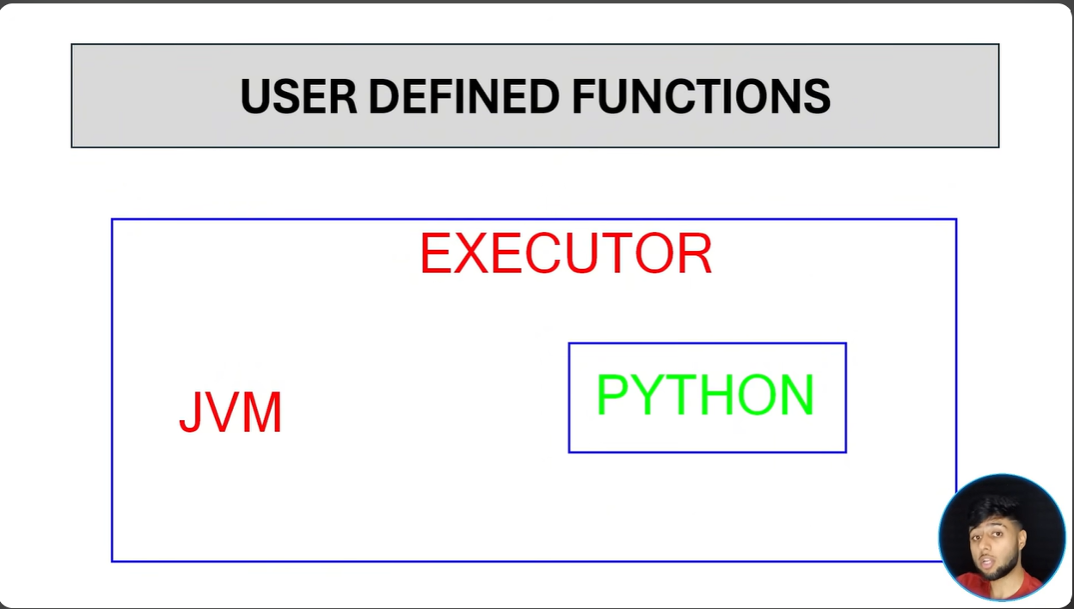
Note: This should be used if only necessary particularly when you realize that no functions are already available in PySpark libraries to customize the requirement, because pyspark has overhead of adding an python interpreter unnecessarily.

